CREATION OF EC2 INSTANCE USING CLOUD FORMATION

**Security group template:**

AWSTemplateFormatVersion: '2010-09-09'

Parameters:

  VpcId:

    Type: 'AWS::EC2::VPC::Id'

    Description: 'ID of the existing VPC'

Resources:

  MySecurityGroup:

    Type: 'AWS::EC2::SecurityGroup'

    Properties:

      GroupDescription: 'Allow SSH and HTTP traffic'

      VpcId: !Ref VpcId

      SecurityGroupIngress:

        - IpProtocol: 'tcp'

          FromPort: 22

          ToPort: 22

          CidrIp: '0.0.0.0/0'

        - IpProtocol: 'tcp'

          FromPort: 80

          ToPort: 80

          CidrIp: '0.0.0.0/0'

Outputs:

  SecurityGroupId:

    Description: 'ID of the newly created security group'

    Value: !Ref MySecurityGroup

**VPC template:**

AWSTemplateFormatVersion: '2010-09-09'

Resources:

  MyVPC:

    Type: 'AWS::EC2::VPC'

    Properties:

      CidrBlock: '10.0.0.0/16'

      EnableDnsSupport: 'true'

      EnableDnsHostnames: 'true'

      Tags:

        - Key: 'Name'

          Value: 'MyVPC'

  PublicSubnetA:

    Type: 'AWS::EC2::Subnet'

    Properties:

      VpcId: !Ref MyVPC

      CidrBlock: '10.0.1.0/24'

      AvailabilityZone: 'us-east-1a'

      MapPublicIpOnLaunch: 'true'

      Tags:

        - Key: 'Name'

          Value: 'PublicSubnetA'

  PublicSubnetB:

    Type: 'AWS::EC2::Subnet'

    Properties:

      VpcId: !Ref MyVPC

      CidrBlock: '10.0.2.0/24'

      AvailabilityZone: 'us-east-1b'

      MapPublicIpOnLaunch: 'true'

      Tags:

        - Key: 'Name'

          Value: 'PublicSubnetB'

  InternetGateway:

    Type: 'AWS::EC2::InternetGateway'

    Properties:

      Tags:

        - Key: 'Name'

          Value: 'InternetGateway'

  AttachGateway:

    Type: 'AWS::EC2::VPCGatewayAttachment'

    Properties:

      VpcId: !Ref MyVPC

      InternetGatewayId: !Ref InternetGateway

  PublicRouteTable:

    Type: 'AWS::EC2::RouteTable'

    Properties:

      VpcId: !Ref MyVPC

      Tags:

        - Key: 'Name'

          Value: 'PublicRouteTable'

  PublicRoute:

    Type: 'AWS::EC2::Route'

    DependsOn: AttachGateway

    Properties:

      RouteTableId: !Ref PublicRouteTable

      DestinationCidrBlock: '0.0.0.0/0'

      GatewayId: !Ref InternetGateway

  AssociatePublicSubnetA:

    Type: 'AWS::EC2::SubnetRouteTableAssociation'

    Properties:

      SubnetId: !Ref PublicSubnetA

      RouteTableId: !Ref PublicRouteTable

  AssociatePublicSubnetB:

    Type: 'AWS::EC2::SubnetRouteTableAssociation'

    Properties:

      SubnetId: !Ref PublicSubnetB

      RouteTableId: !Ref PublicRouteTable

**EC2 template:**

AWSTemplateFormatVersion: '2010-09-09'

Parameters:

  KeyName:

    Type: 'AWS::EC2::KeyPair::KeyName'

    Description: 'Name of an existing EC2 KeyPair to enable SSH access to the instance'

  SubnetId:

    Type: 'AWS::EC2::Subnet::Id'

    Description: 'ID of the existing subnet where the instance will be launched'

  InstanceType:

    Description: WebServer EC2 instance type

    Type: String

    Default: t2.micro

    AllowedValues: [t2.nano, t2.micro, t2.small, t2.medium, t2.large, t2.xlarge, t2.2xlarge]

    ConstraintDescription: must be a valid EC2 instance type.

  EbsVolumeSize:

    Type: Number

    Default: 8

    Description: 'Size of the EBS volume in GiB'

  AdditionalVolumeSize:

    Type: Number

    Default: 20

    Description: 'Size of the additional EBS volume in GiB'

Resources:

  MyInstance:

    Type: 'AWS::EC2::Instance'

    Properties:

      InstanceType: !Ref InstanceType

      ImageId: 'ami-0c7217cdde317cfec'

      KeyName: !Ref KeyName

      SubnetId: !Ref SubnetId

      BlockDeviceMappings:

        - DeviceName: "/dev/sda1"

          Ebs:

            VolumeSize: !Ref EbsVolumeSize

        - DeviceName: "/dev/sdb"

          Ebs:

            VolumeSize: !Ref AdditionalVolumeSize

      SecurityGroupIds:

        - 'sg-010f7a25dfa201718'

Outputs:

  InstanceId:

    Description: 'Instance ID of the newly created EC2 instance'

    Value: !Ref MyInstance

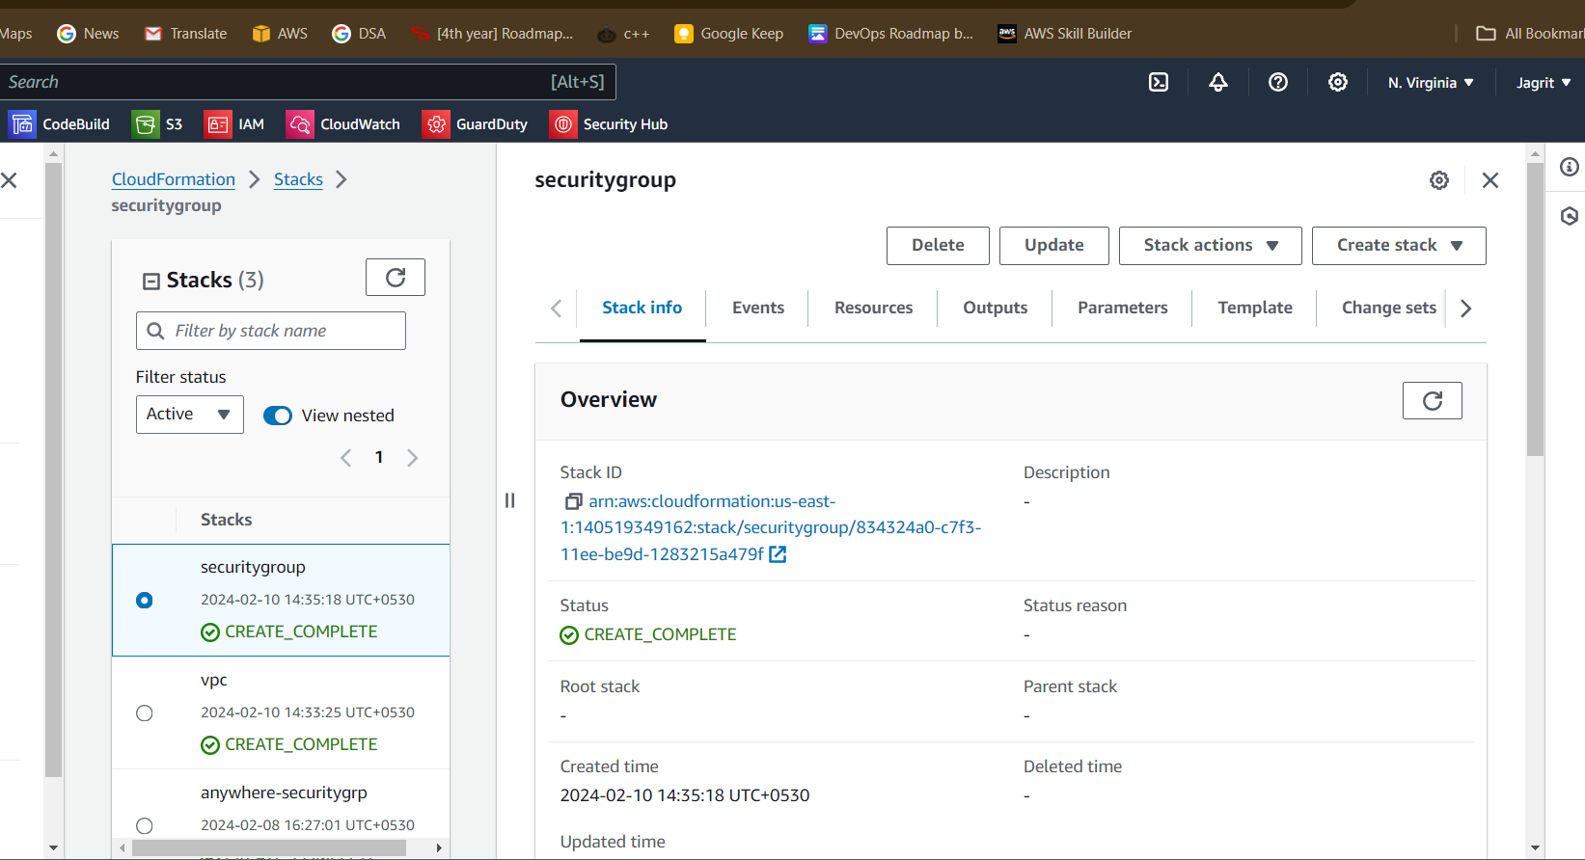security group

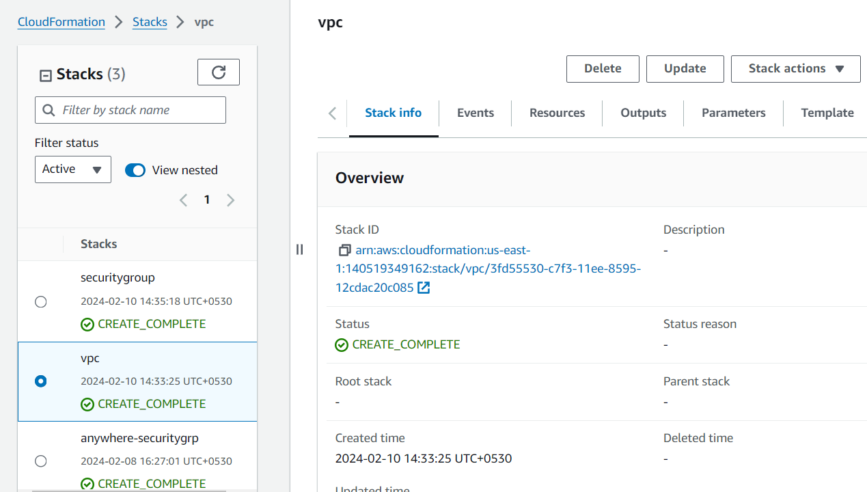

Vpc

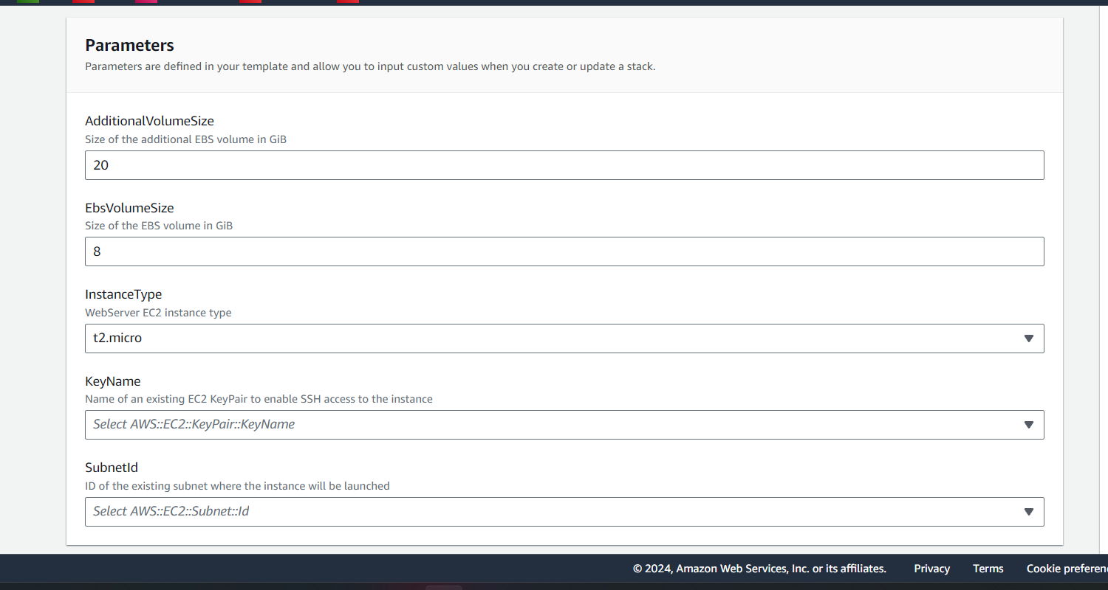

Ec2